SCR2043 OPERATING SYSTEMS

Name | : | MUHAMMAD AFIQ DANIAL BIN ROZAIDIE |  |  |  | Marks
Student ID | : | A23CS0117
Section | : | 02

This lab assessment is designed to test your understanding and skills on some basic concepts and tools related to process monitoring and management in operating system. Please follow the instructions carefully and submit your answers in this word document and rename the file as os-lab-assessment02-studentname-matricno.docx.

Essential Steps Before Starting Lab Assessment 2:
- Download necessary source codes:
Use the wget command to retrieve the following source code files to your Linux (or WSL or MacOS) environment:
wget -O mainprocess.c https://rebrand.ly/mainprocess_c
wget -O subprocess1.c https://rebrand.ly/subprocess1_c
wget -O subprocess2.c https://rebrand.ly/subprocess2_c

- Compile the source files:
Use the gcc compiler to create executable files from the source code.
gcc mainprocess.c -o mainprocess
gcc subprocess1.c -o subprocess1
gcc subprocess2.c -o subprocess2

- Execute the dummy processes:
Run all the dummy processes
./mainprocess &

Press enter two times.
- The dummy processes are running for 2 hours. If you took longer than 2 hours on questions 1-9, please restart the main process with ./mainprocess &.
Lab Assessment 2 : Linux Process Monitoring and Management
Instructions:
- Carefully execute each command as instructed in the questions.
- Write down the exact command used for each task.
- Capture a screenshot of the command's output.

Question 1
Use the ps command with the appropriate option to display a complete list of all running processes within the Linux operating system.

Command
ps -e
Output
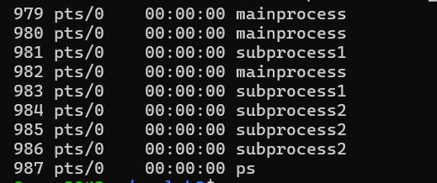

Question 2
Employ the ps command with necessary options to unveil comprehensive details about each running process.

Command
ps -ef | grep -E ‘mainprocess|subprocess’

Output
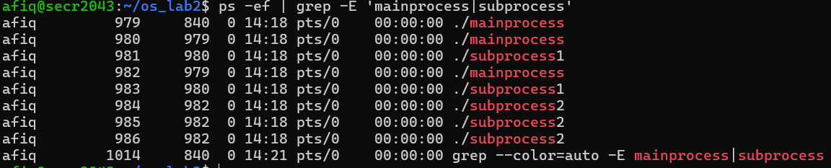

Question 3
Use the ps command with some tools to only list processes named "subprocess" and show some info about them.

Command
ps -ef | grep subprocess
Output
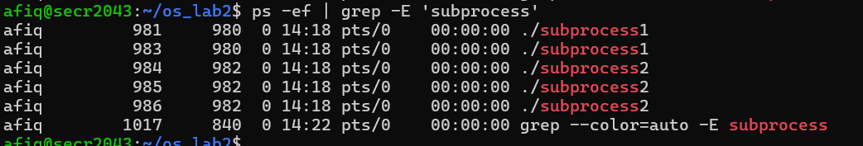

Question 4
Execute the ps command, specifying options that reveal only the following columns:
- Process ID (pid)
- Owner of the process (user)
- CPU percentage (pcpu)
- Memory percentage (pmem)
- Command (cmd)

Command
ps -eo pid,user,pcpu,pmem,cmd | grep -E ‘subprocess’
Output
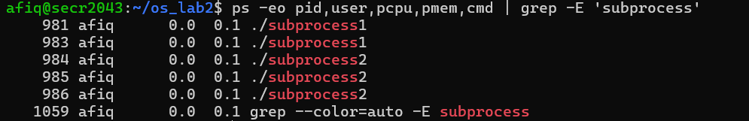

Question 5
Building on the ps command used in Question 4, can you add an option to sort the listed processes by their memory usage (pmem)?

Command
ps -eo pid,user,pcpu,pmem,cmd –sort=pmem | grep -E ‘subprocess’
Output
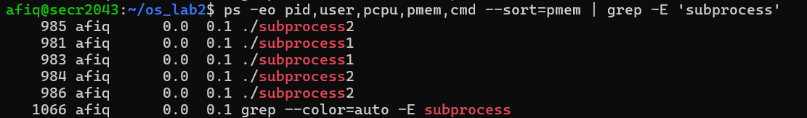

Question 6
Construct a command using ps, suitable options, and any additional tools to visualize the hierarchical structure (tree-like) of the following processes:
- "mainprocess"
- "subprocess1"
- "subprocess2"
Command
ps –forest -C mainprocess -C subprocess1 -C subprocess2

Output
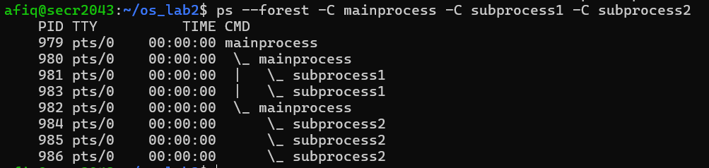

Question 7
Use pstree command with option that show the number of threads to each process.

Command
pstree -c -s 979

Output
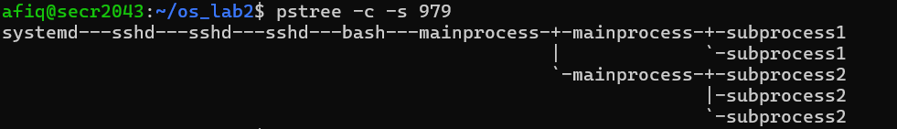

Question 8
Use renice command to change priority level of one of process “subprocess1”.

Command
sudo renice -n -10 -p 981

Output
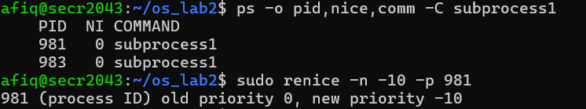

Question 9
Terminate all running processes with the name “mainprocess”.

Command
pkill mainprocess

Output
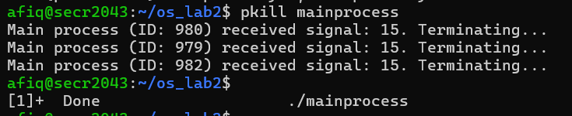

Question 10
Write a short C or Python code (choose only one language) demonstrating multiprocessing with fork() and wait(). Compile and/or run the code. Show the output.
Source Code:
#include <stdio.h>
#include <stdlib.h>
#include <unistd.h>
#include <sys/wait.h>

int main() {
pid_t pid;

printf("Starting the program...\n");

pid = fork(); // Create a new process

if (pid < 0) {
perror("fork failed");
exit(1);
} else if (pid == 0) {
// Child process
printf("Child process (PID: %d): Doing some work...\n", getpid());
sleep(2);
printf("Child process: Finished work.\n");
} else {
// Parent process
printf("Parent process (PID: %d): Waiting for child to finish...\n", getpid());
wait(NULL); // Wait for the child process to finish
printf("Parent process: Child finished. Exiting.\n");
}

return 0;
}
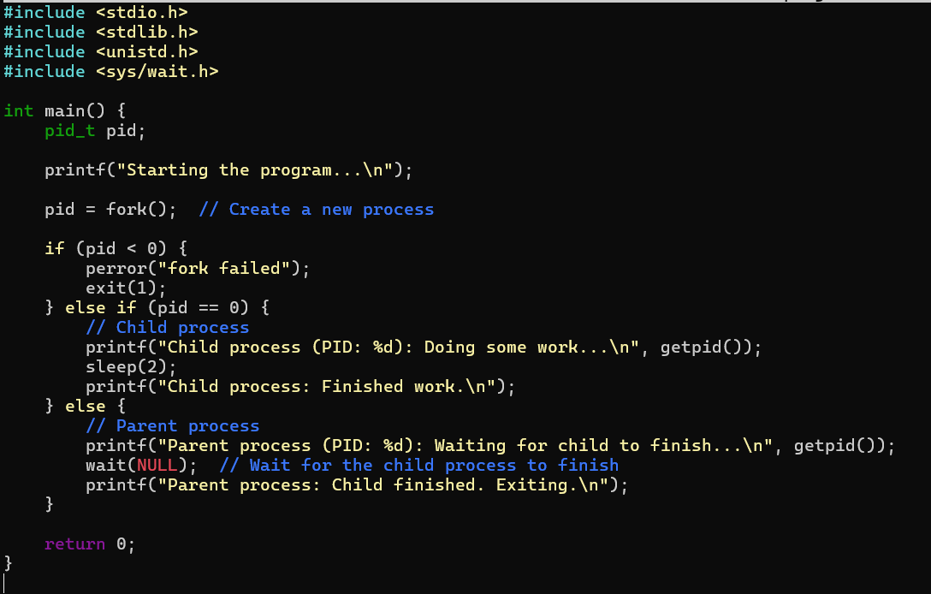

Output:
